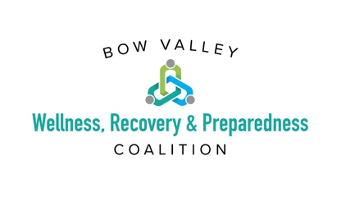
SeeTheSigns Campaign: Suggested Newsletter Copy

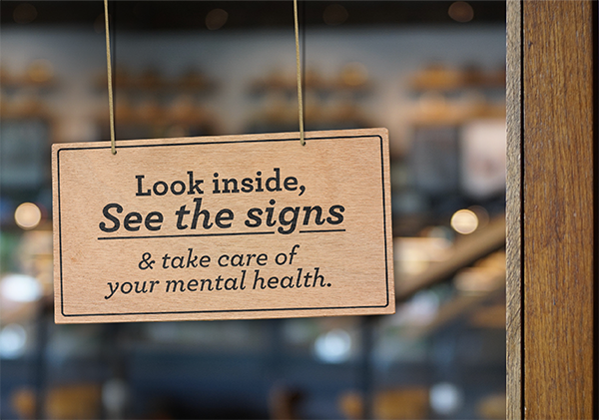

What’s “normal”?
Whatever you're feeling is perfectly normal.

That said, signs of good mental health include being aware of your abilities, being able to cope with the stresses of daily life, being able to work productively, and being able to participate in your community. If you feel detached from the people around you, overwhelmed by stress, or too distracted or distraught to be productive, those are all signs that your mental health may be struggling.

If you see the signs, there are resources and support services available to you. Visit seethesigns.ca.

